Application fee payment

Application fee can be paid through State Bank Collect.
- Visit our website www.sme.edu.in and click on the “Application Fee Payment” link. State Bank Collect window will be opened as shown in the figure1.
- Click check box and proceed

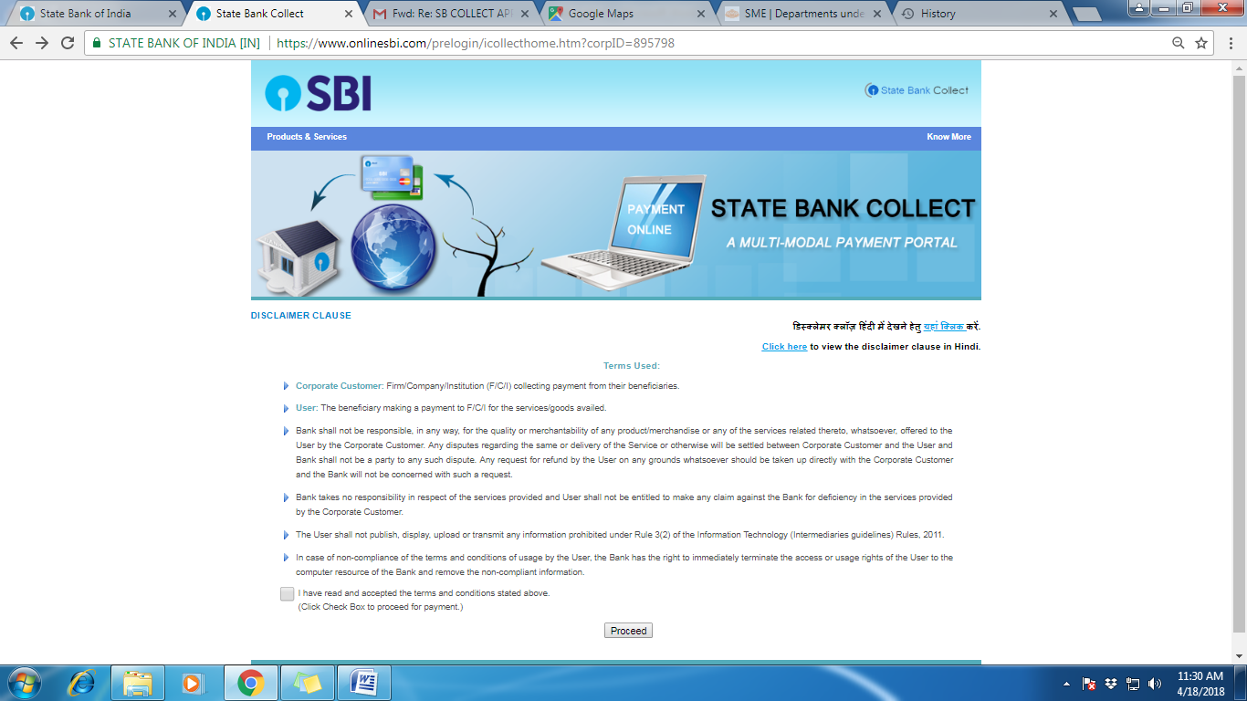

- Payment window for Centre for Professional and Advanced Studies will be opened as in the figure 2.
- From the payment category select the School/ College/ Institute where you want to apply.

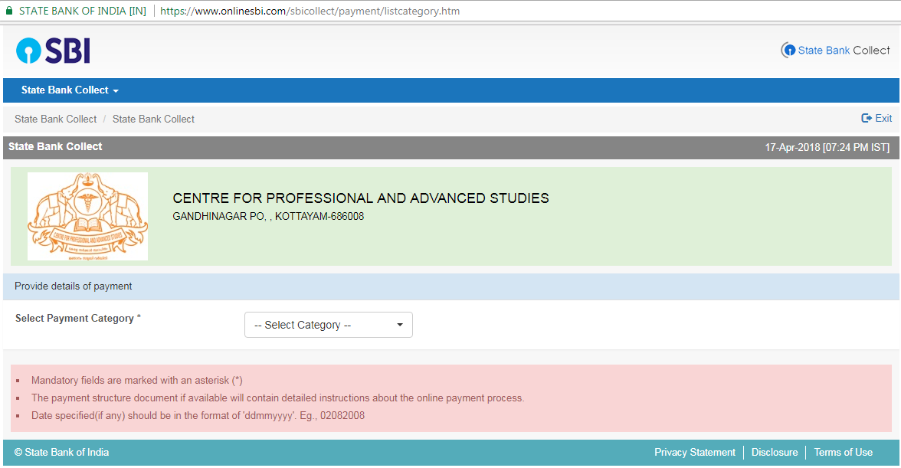
- Fill the details in the next window (figure3). No special charectors (,@#$%^&* etc) are allowed in any column.

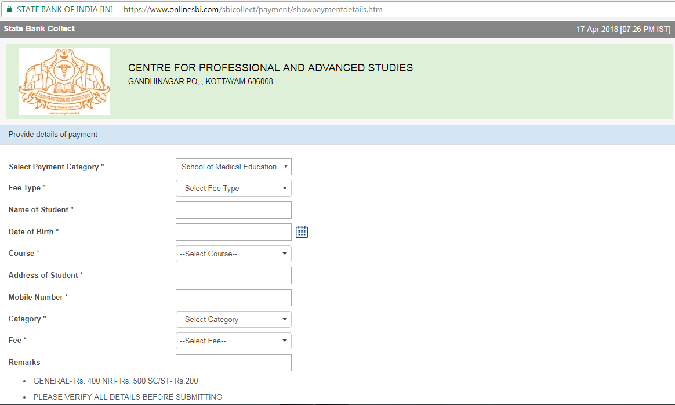
\

- After submission of above details applicant will be directed to a multi option payment system (figure 4)
- Here student can make payment through any one of the six methods given.
i)Net banking via State bank of India, ii)Net banking via any other banks, iii)Card payment using SBI ATM card, iv)Card payment using other bank debit cards, v)Card payment using Credit cards, vi)Direct payment in any brach of SBI

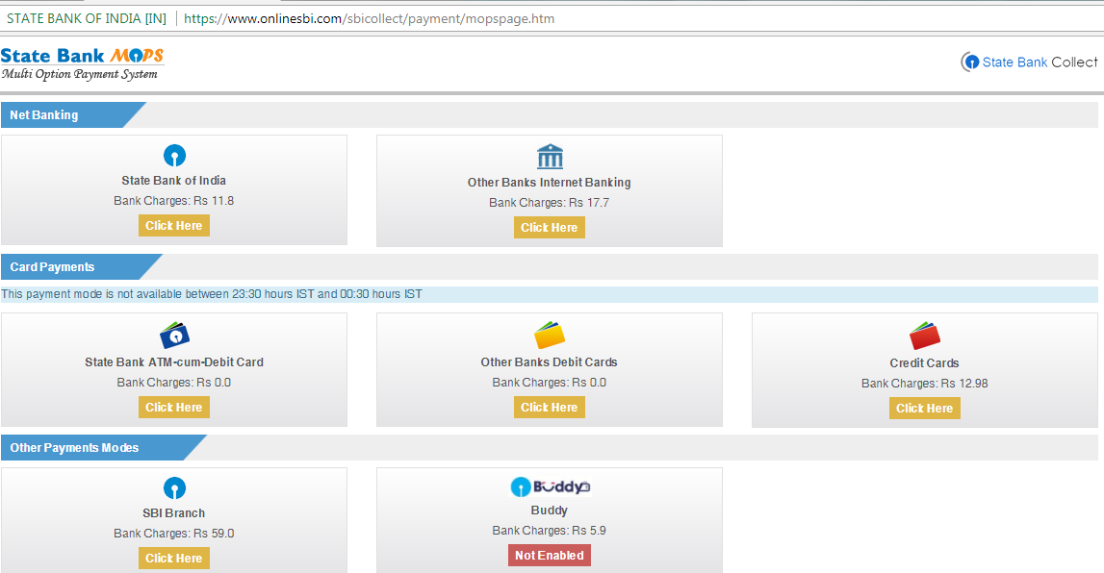
- If you select the payment at the SBI brach, a window as in figure 5 will appear with your details.
- Take the print out of the ‘pre- Acknowledgement form’ given at the bottom of the window.

- Model pre acknowledgement form is given in figure 6.
- Make payment in any branch of State bank of India using the print out of pre acknowledgement form of the applicant.

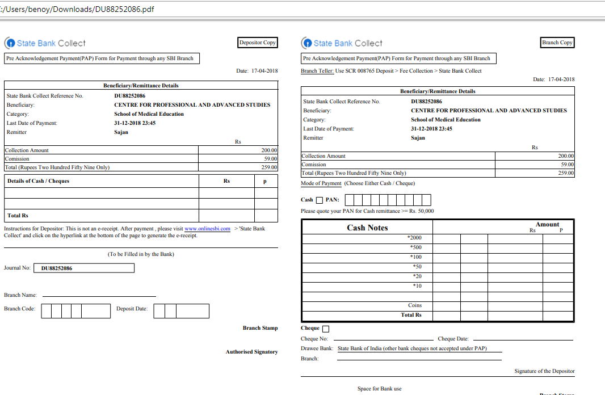
- After payment Candidates copy should be attached with the application as the proof of application fee payment.
- For future reference applicants may keep the photocopy or DU reference number of the pre acknowledgement.
- Applicants using the payment mode other than Pay at SBI Branch also should take the print out of the payment receipt and attach the same with the application form.

